Elephant Worksheet 2 Name________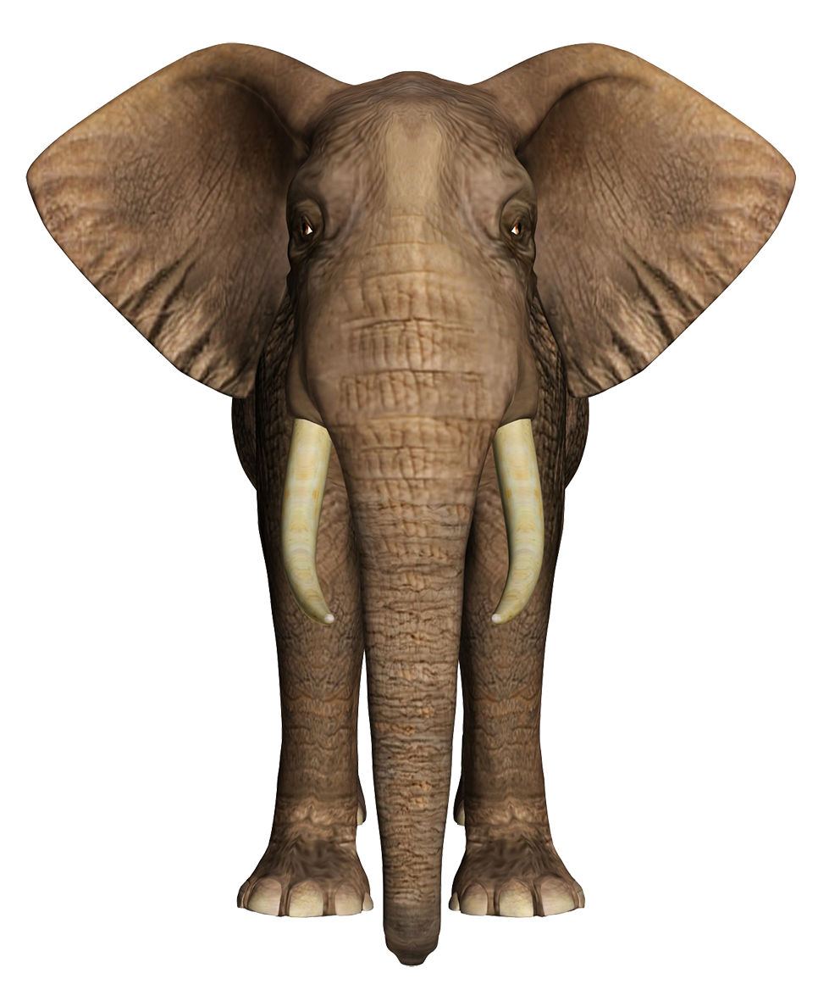

*I can* ***explain*** *how density-dependent and density independent factors impact elephant populations*

*I can collect evidence to support the claim that cooperation increases fitness*

*I can compare and contrast types of reproductive strategies*

*I can explain the selective pressure that has been placed on a tuskless elephant population*

| Investigate: Elephant Tusks  -Both [**male**](https://s-media-cache-ak0.pinimg.com/originals/95/45/ef/9545ef4bab63bd476e51c7a013fd612f.jpg) and [**female**](https://upload.wikimedia.org/wikipedia/commons/6/65/Female_African_bush_elephant_(Loxodonta_africana)_with_juvenile,_Daures,_Erongo,_Namibia.jpg) elephants have tusks, which start to grow in after [**baby elephants**](http://7-themes.com/data_images/out/42/6913515-elephant-mother-baby.jpg) lose their primary teeth in their first year of life.  -Elephants use their tusks all the time. “[**Prying bark from trees**](https://www.awf.org/blog/going-tuskless); digging for water, roots, or minerals; [or] fighting other bull elephants—tusks perform a variety of functions.”    **Measure** the elephant tusk shown in diagram in cm  The pulp cavity is connected to the elephant’s face. How much of the tusk is in the elephant’s skull?  Look at a 3D model of an elephant skull. **Pose** a question about elephant tusks |
| --- |

# http://www.nationalgeographic.com/interactive-assets/elephant-census/v3/assets/img/elephant.png

# **Claim:** Cooperative Behavior increases fitness and success of young elephants.

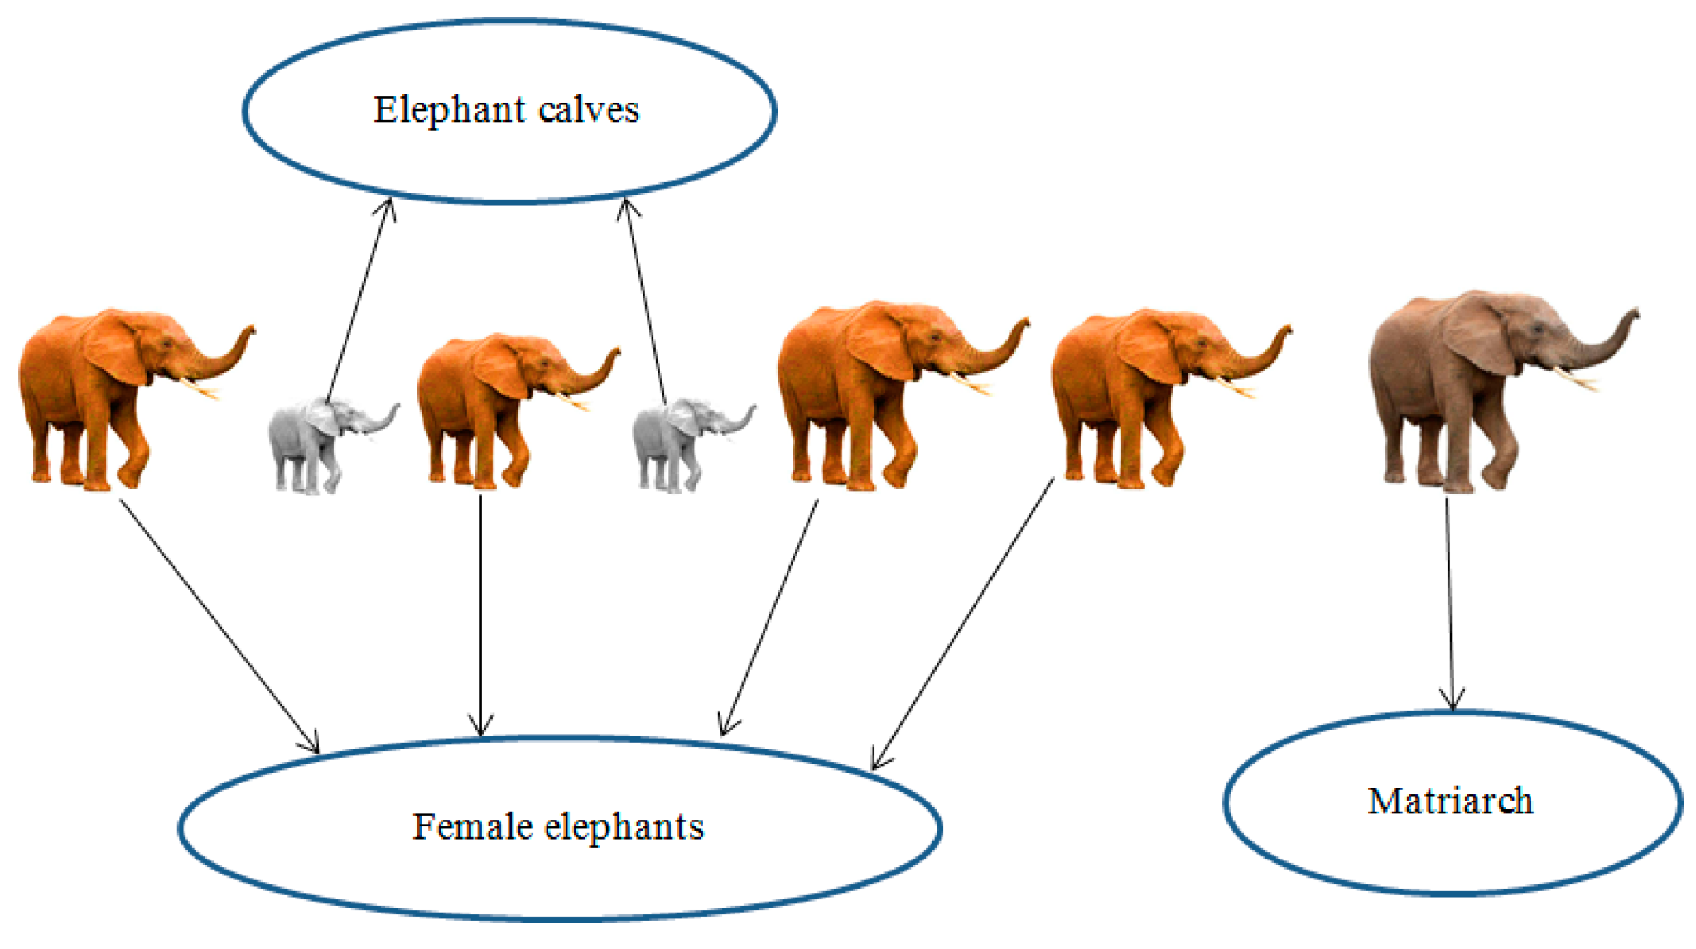

Elephants live in **tightly-bonded female-led herds**. This is led by the oldest and often largest female in the herd, called a matriarch. Herds usually consist of 8-100 individuals, depending on terrain and family size. When a calf is born, it is raised and protected by the whole matriarchal herd.

# 

Using the graphs, provide at least 2 pieces of evidence to support claim

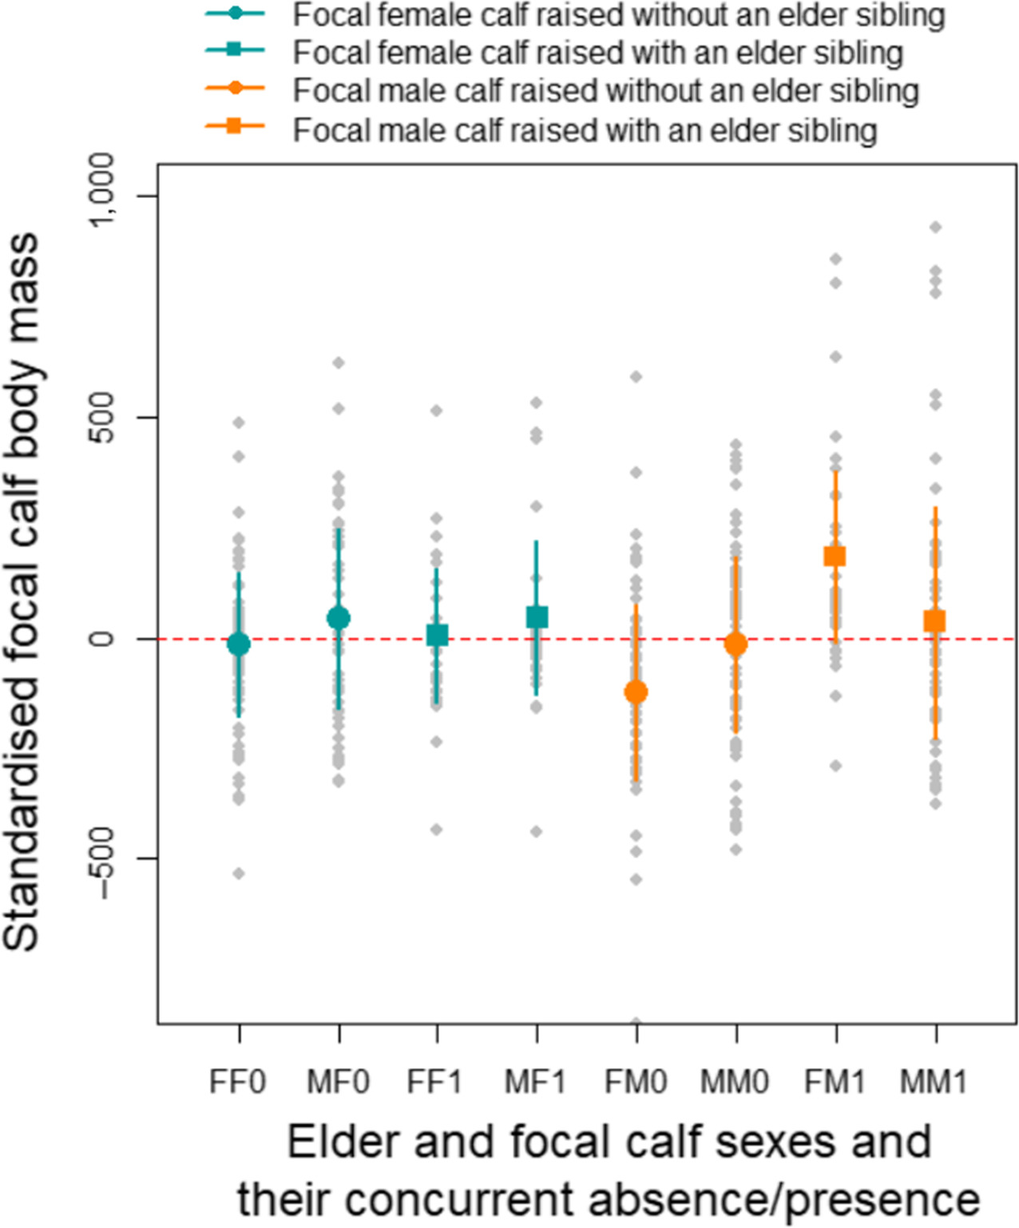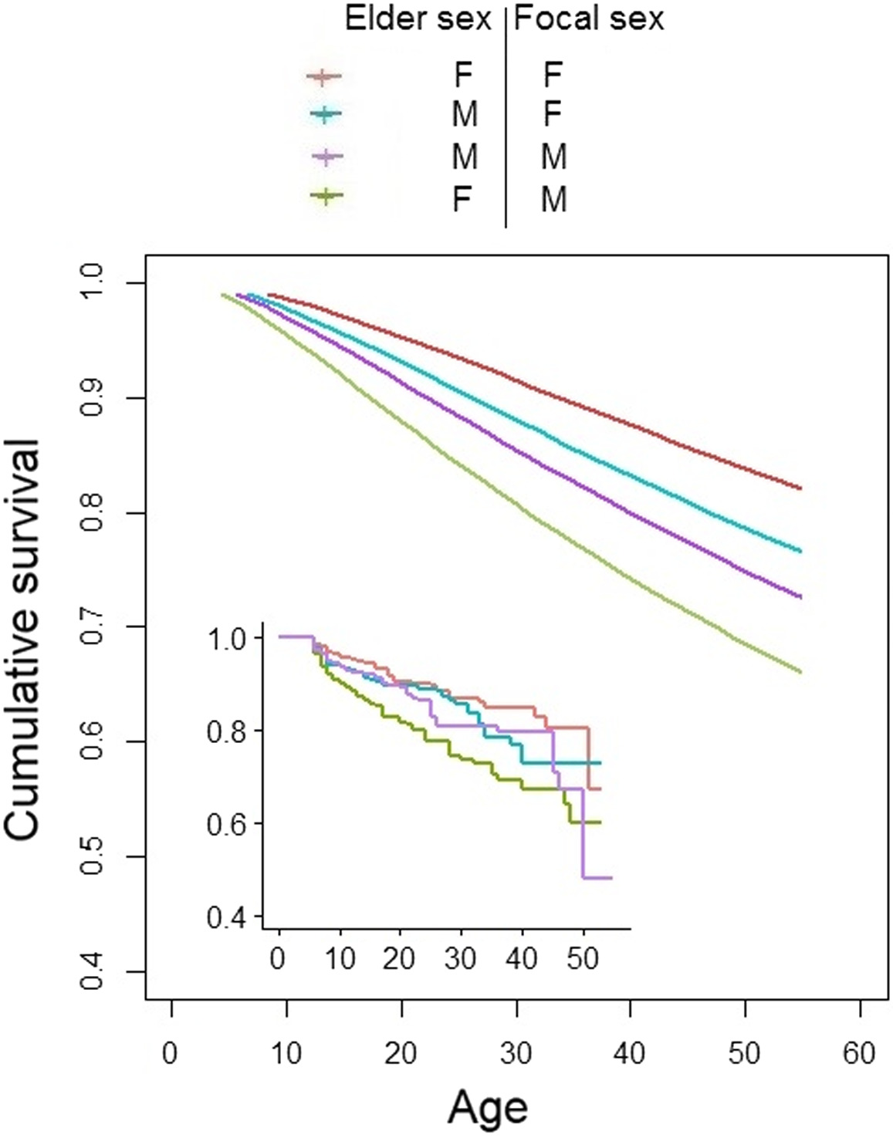

Elephants are K species. Did you know that they are pregnant for 18-22 months?? How might this slow the conservation effort to save elephants?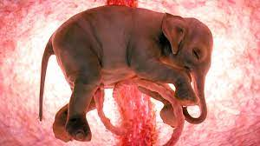

**What is the advantage to k-selection**? Disadvantage?

**What is the advantage to r-selection**? Disadvantage?

Optional: Meet the orphan calves

**https://elephantswithoutborders.org/elephant-orphanage/meet-the-calves/**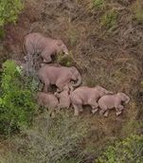

| Populations of Elephants  What makes a population?  What are **density dependent factors** that affect elephants?  What are **density independent factors** that affect elephants? |
| --- |

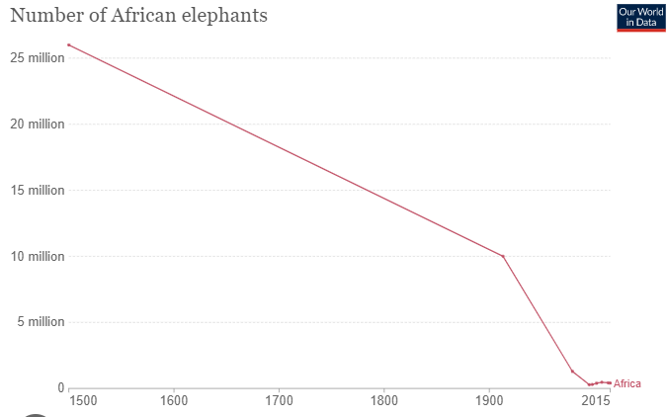

Using info from graph, How have African elephant populations changed over time?

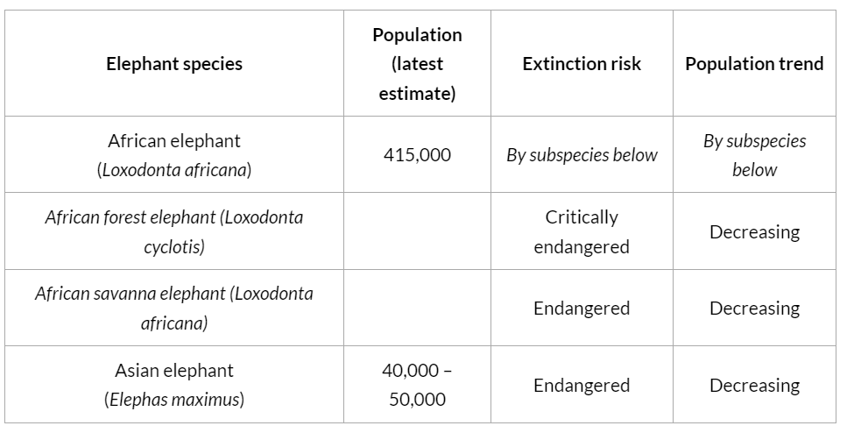

Using the data table, what species are at risk of extinction today?

| **Threats elephants face**  Read information from the San Diego Zoo website regarding population statistics to see what common threats elephants face: <http://ielc.libguides.com/c.php?g=692888&p=4908857>  Threat Notes  -  **Watch: How much is your face worth?**  What stood out from this PSA? |
| --- |

| Tusklessness population case study  .    Watch the video clip at <http://www.hhmi.org/biointeractive/selection-tuskless-elephants>  Use the following data and information from the video to answer the questions that follow.  What is unusual about the elephant populations found in Gorongosa now?  How does an elephant use its tusks?  What would probably happen to a male elephant that doesn’t have tusks?  Therefore, tusklessness in male elephants is a (rare/common) trait.  How did the civil war affect elephant populations?  Dr. Poole noticed a high proportion of tuskless elephants after the war. But why did males still have their tusks?  What was the selective pressure that increased the numbers of tuskless elephants?    Explain how this selective pressure shifted the population to be more tuskless.  Write an explanation based on natural selection for the high incidence of tusklessness among female elephants in Gorongosa.Highlight vocab: variation, differential reproduction, trait, variation, inherit, DNA |
| --- |



| In elephants, no tusks (t) is sex-linked recessive tusks (T). If a tuskless female mates with a male with tusks, what % females and males will be tusk-less?  %__tusk-less females  %__tusk-less males  2) In elephants, no tusks (t) is sex-linked recessive tusks (T). If a pure tusked female mates with a male without tusks, what % females and males will be tusk-less?  %__tusk-less females  %__tusk-less males  3) In elephants, big ears eyes (E) is dominant to small ears(e). If two heterozygous parents mate, what percent will have small ears?  %__small ears  4) In elephants, big ears eyes (E) is dominant to small ears(e). If a homo dominant parent mate with a homo recessive parent, what percent will have small ears?  %__small ears |
| --- |

Elephants of Tanzania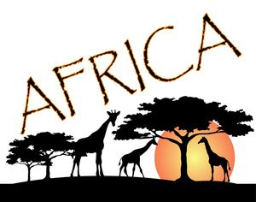

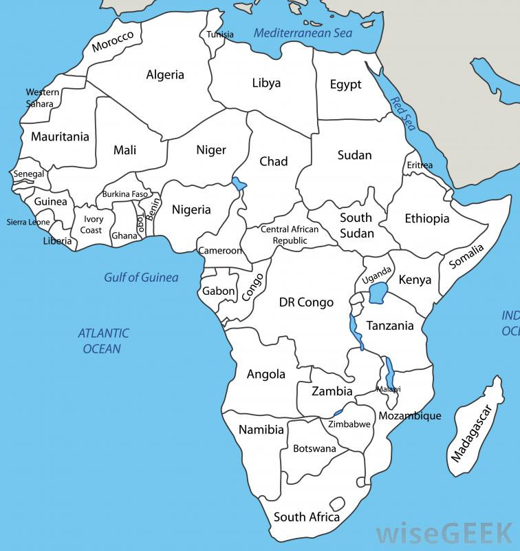



1. Color Tanzania on map
2. Scan, read, and describe https://tanzania.wcs.org/Species/Elephant.aspx

| **Describe** the state of elephants of Zimbabwe |
| --- |